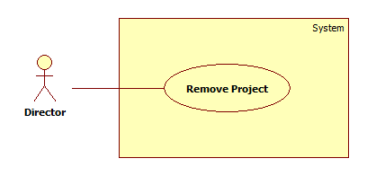

|  |  |  |  |
| --- | --- | --- | --- |
| **USE CASE – UC002** | | | |
| **Use Case No.** | UC010 | **Use Case Version** | 1.0 |
| **Use Case Name** | Remove Project | | |
| **Author** | ToanLC | | |
| **Date** | 03-06-2015 | **Priority** | Normal |
| **Actor:**   * Director   **Summary:**   * This use case allows director to remove the project.   **Goal:**   * Project is removed.   **Triggers:**   * Director click the Remove button on Project details page.   **Preconditions**:   * Log into the system with Director Role. * Project is existed.   **Post Conditions:**   * **Success**: Project is removed. * **Fail**: System shows error message.   **Main Success Scenario:**   |  |  |  | | --- | --- | --- | | Step | Actor Action | System Response | | 1 | Director choose “View detail” the project which want to remove on List Project page. | System shows the Project Detail Page | | 2 | Director click “Remove” button. | System shows message box “Are you sure you want to delete this project?” with 2 option “Remove” and “Cancel”. | | 3 | Director choose option “Remove”.  [Alternative 1] | System deletes Project in database. Back to List Project Page and show message “Project was successfully deleted” |   **Alternative Scenario:**   |  |  |  | | --- | --- | --- | | No | Actor Action | System Response | | 1 | Director choose option “Cancel”. | System close message box. |   **Exceptions:**   |  |  |  | | --- | --- | --- | | No | Actor Action | System Response | |  |  |  |   **Relationships**: N/A  **Business Rules:**   * Member joined in the project won’t be deleted. * When a project was closed, all tasks belong to it will be deleted. | | | |

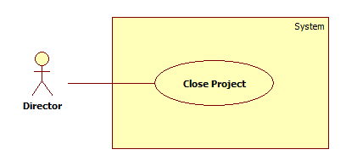

|  |  |  |  |
| --- | --- | --- | --- |
| **USE CASE – UC002** | | | |
| **Use Case No.** | UC011 | **Use Case Version** | 1.0 |
| **Use Case Name** | Close Project | | |
| **Author** | ToanLC | | |
| **Date** | 03-06-2015 | **Priority** | Normal |
| **Actor:**   * Director   **Summary:**   * This use case allows director to close a project after review project.   **Goal:**   * The project status is changed to “Close”.   **Triggers:**  Director clicks the “Close” button on Project details Page.  **Preconditions**:   * Log into the system with Director Role.   **Post Conditions:**   * **Success**: The project status is changed to “Closed”. * **Fail**: System shows error message.   **Main Success Scenario:**   |  |  |  | | --- | --- | --- | | Step | Actor Action | System Response | | 1 | Director choose “View detail” the project want to close on List project page. | System shows the Project Detail Page. | | 2 | Director click “Close” button. | System shows message box “Are you sure you want to close this project?” with 2 option “Close” and “Cancel”. | | 3 | Director choose option “Close”. | System update the project status in database. Back to the project detail page with the project status was changed. |   **Alternative Scenario:**   |  |  |  | | --- | --- | --- | | No | Actor Action | System Response | | 1 | Director clicks “Cancel” button. | System do nothing. |   **Exceptions:**   |  |  |  | | --- | --- | --- | | No | Actor Action | System Response | |  |  |  |   **Relationships**: N/A  **Business Rules:**   * Member still can enter the project when it was closed. * Director will review see that all task is done before closing project. | | | |

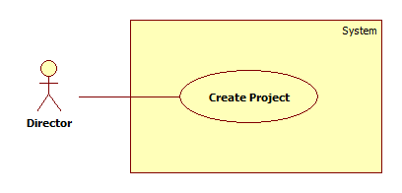

|  |  |  |  |
| --- | --- | --- | --- |
| **USE CASE – UC002** | | | |
| **Use Case No.** | UC012 | **Use Case Version** | 1.0 |
| **Use Case Name** | Create Project | | |
| **Author** | ToanLC | | |
| **Date** | 03-06-2015 | **Priority** | Normal |
| **Actor:**   * Director   **Summary:**   * This use case allows director to create a new project.   **Goal:**   * New Project is created.   **Triggers:**  Director clicks “Create Project” button on the list project page.  **Preconditions**:   * Log into the system with Director Role.   **Post Conditions:**   * **Success**: New project are created. * **Fail**: System shows error message.   **Main Success Scenario:**   |  |  |  | | --- | --- | --- | | Step | Actor Action | System Response | | 1 | Director clicks “Create Project” button on the list project page. | System shows a popup contains “Project ID”: disabled textbox   * “Project Name”: textbox required * “Creator”: textbox (default is director account) * “Start date”: datetime picker * “Deadline”: datetime picker * “Assignee”: textbox * “Need Skills:”: textbox * “Create”: button * “Cancel”: button | | 2 | Director inputs requested data |  | | 3 | Director clicks “Create” button | System closes current window and back to the list project page with the new project.  [Exception 1, 2, 3, 4] |   **Alternative Scenario:**   |  |  |  | | --- | --- | --- | | No | Actor Action | System Response | | 1 | Director clicks “Cancel” button. | System close the create popup. |   **Exceptions:**   |  |  |  | | --- | --- | --- | | No | Actor Action | System Response | | 1 | Project name is empty. | System shows message “can’t be blank”. | | 2 | Start date after Deadline. | System shows message “Start date should be set before Deadline”. | | 3 | Project name is existed | System shows message “The project name is existed | | 4 | Assignee is empty | System shows message “can’t be blank”. | |  |  |  |   **Relationships**: N/A  **Business Rules:**   * Project was created without assignee turn to new status. | | | |